Fernando Gonzales-Vigil

Project 1

**Test Plan**

|  |  |  |  |  |  |
| --- | --- | --- | --- | --- | --- |
| Variable / Constant | Constant Value | Test #1 | Test #2 | Test# 3 | Test #4 |
| ROBOT_NAME | Omnius |  |  |  |  |
| PROGRAMMER_NAME | Fernando Gonzales-Vigil |  |  |  |  |
| userName |  | Rebort | Fernando | Bob | Lisa |
| age |  | 2 | 40 | 75 | 10 |
| ageInMonths |  | 24 | 480 | 900 | 240 |
| ageInDays |  | 730 | 14600 | 27375 | 3650 |
| ageInHours |  | 17520 | 350400 | 657000 | 87600 |
| ageInMinutes |  | 1051200 | 21024000 | 39420000 | 5256000 |
| ageInSeconds |  | 63072000 | 1261440000 | 2365200000 | 315360000 |
| ageOfDog |  | 14 | 280 | 525 | 70 |
| ageOfGoldfish |  | 10 | 200 | 375 | 50 |
| firstNumber |  | 4 | 5 | 20 | 11 |
| secondNumber |  | 5 | 4 | 10 | 17 |
| firstDoubleNumber |  | 4.0 | 5.0 | 20.0 | 11.0 |
| secondDoubleNumber |  | 5.0 | 4.0 | 10.0 | 17.0 |
| sum |  | 9 | 9 | 30 | 28 |
| integerQuotient |  | 0 | 1 | 2 | 0 |
| DoubleQuotient |  | 0.8 | 1.3 | 2.0 | 0.6 |

*Yellow Cells are values by user input

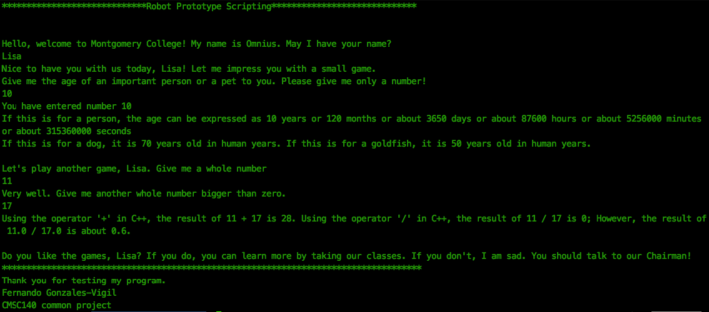

Start Program

Present robot to user and ask for user name

Retrieve username from keyboard.

Ask the user for age of person or pet



Retrieve age from keyboard.



Show calculations made with age provided by user



Ask the user for a whole number



Retrieve first number from keyboard.

Ask the user for a second whole number



Retrieve second number from keyboard.



Show calculations made with provided numbers and show exit message



End Program

Lesson Learned:

* Check for constraints and correct: Even when assignment says to ask for whole number, definition of whole numbers include 0. When using 0 as second number, a division by zero happens and this throws error, so you must ask correct information from user.
* Check for overflows: Sometimes we choose int as default data type, but you forget that numbers can grow pretty fast, and when you test possible numbers, like 75 if the person age chose a human age, it will be beyond the limit of int so if the number is going to grow with calculations, think and don’t assume.
* I struggle a bit with the flowchart. Word and Powerpoint, especially in MacOS are not very functional. Maybe I’d try to do the flowchart by hand and include a picture in the next project if possible.

Success! Your submission appears on this page. The submission confirmation number is 10e66bb8-32a3-4ccf-8e15-4177118afef7